**Winter Rudrnath Trek**

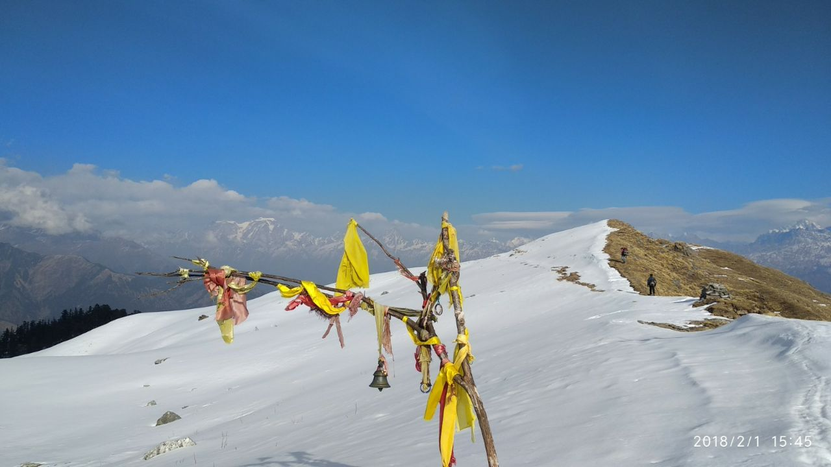

Rudranath (Sanskrit: रुद्रनाथ) is a Hindu temple dedicated to god Shiva, located in the Garhwal Himalayan mountains in Uttarakhand, India. Located at 3,600 metres (11,800 ft) above sea level, this natural rock temple is situated within a dense forest of rhododendron dwarfs and Alpine pastures. The temple is the fourth temple to be visited in the Panch Kedar pilgrimage circuit, comprising five Shiva temples in the Garhwal region. The face (mukha) of god Shiva is worshipped as "Nilkanth Mahadeva" here.

**Trek Details:**

**Route: Gopeshwar – Tolitaal – Panar – Pitardhar – Rudrnath and back to Pitardhar – Anusuyia And Atrimuni Ashram – Mandal – Gopeshwar**

**Day 1: Gopeshwar to tolitaal(tolilake)**

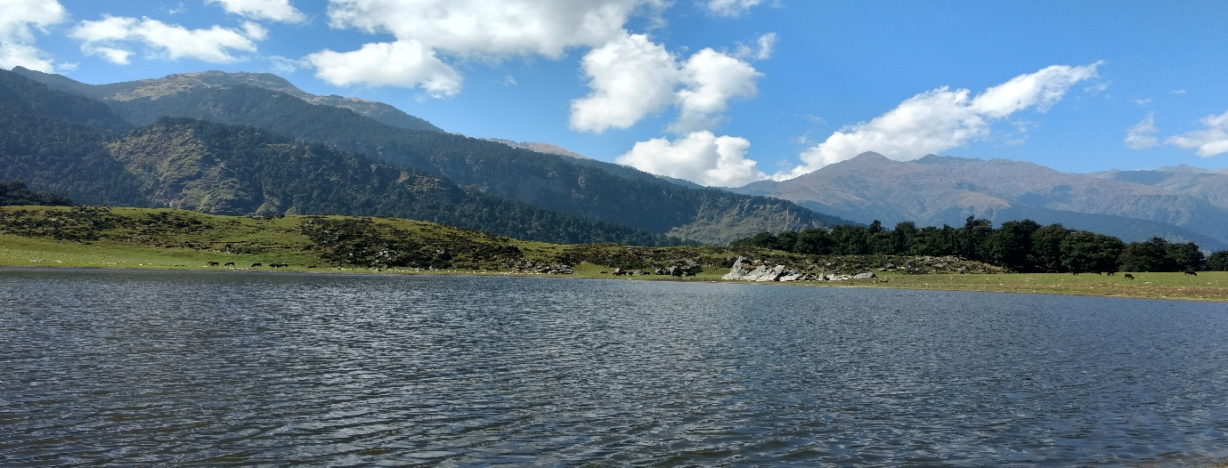**Pic: Tolitaal(Tolilake)**

The trek is started from gopeshwar. Gopeshwar to Kujo village covered by vehicle and than trek point is starting from here. The trek is approximately 10 km passes by dense forest. Initial 8km is steep and mid high mountain region. Then We have to trek rest of 2km downwards to reach the lake . Night stay near at Tolilake .

* **Time taken:**6 hour, 3 km
* **Trek gradient:** Easy. Gradual climb on a well-defined rocky trail, which becomes steeper after the first 10 minutes. 2km descent to the camp site .
* **Water sources:**  Carry around 1 litre of water from Kujo.

**Day 2: Tolitaal – Panar (approximate 5km )**

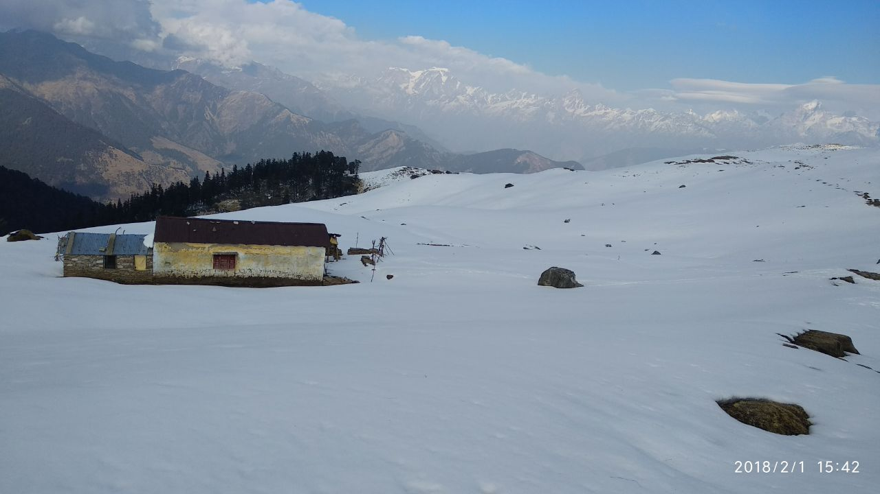

**Pic: Tolitaal(Tolilake)**

After having Breakfast we start our journey towards Panar bugal . In winter season you find snow in this route.

* **Time taken:**3-4hour, 5km
* **Trek gradient:** Gradual climb on a well-defined rocky trail,desce forest, Bugyal which becomes steeper after the first 10 minutes..
* **Water sources:** None. Carry around 1 litre of water from Sari.

**Day 3: Panar – Pitardhar – Rudrnath and back to Pitardhar**

 Situated deep inside the Himalayas, Panar Bugyal offers Majestic and real close up views of the snow clad peaks of Mighty Trishul, Maa Nandadevi, Dronagiri, Hathi and Ghodi and other peaks. The way from Panar to Rudranath is a stretch of beautiful Alpine meadows for kilometres. A Journey that will test you, stretch you out of your comfort zone, exhaust you but also bless you beyond measure.

* **Time taken:**6 hours, 12km
* **Trek gradient:** Straight route towards Rudrnath Temple
* **Water sources:**  carry 2 litres of water while starting from Panar

**Day 4: Panar - Anusuyia And Atrimuni Ashram**

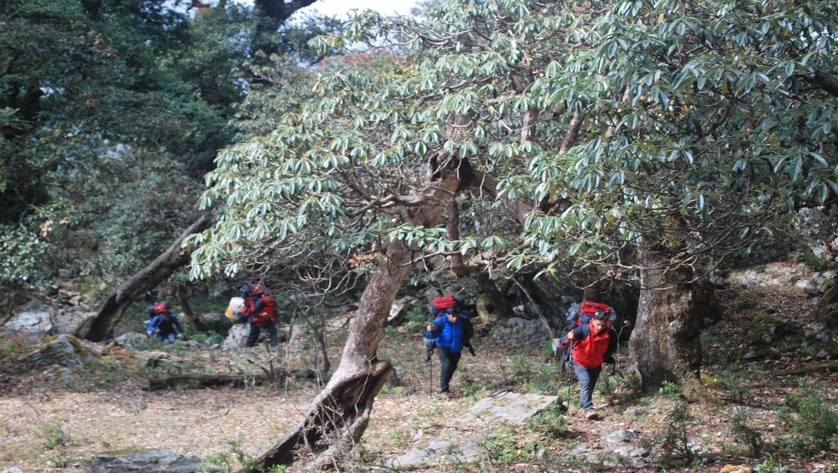

* **Time taken:**6 hours, 14km
* **Trek gradient:**  Moderate. Initial 45 minutes of gradual ascent followed by rapid descent.
* **Water sources:**  carry 2 litres of water while starting from Panar

**Day 5: Anusuyia And Atrimuni Ashram- Mandal-Gopeshwar**

* **Time taken:**3 hours, 15km (including 10km route by vichel )
* **Trek gradient:**  Moderate. Initial 45 minutes of gradual ascent followed by rapid descent.
* **Water sources:**  carry 2 litres of water while starting from Panar

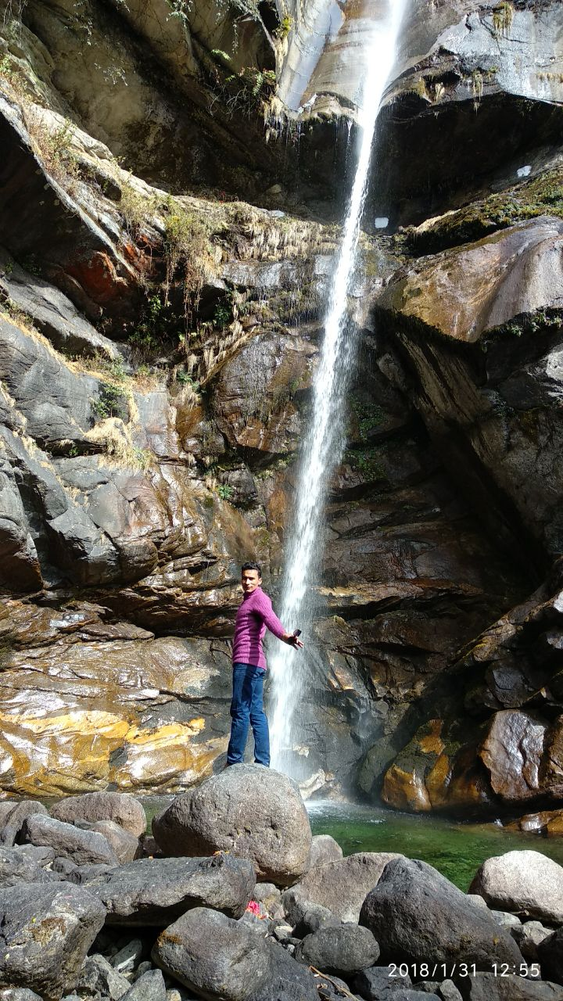

**Pic: Amtritganga waterfall**

**TREK PACKAGES: (including camping, food ,beverage, forest pass, Authority permission, walking sticks & other camping gears )**

**4 night 5days: 11499* INR per person**

**(including 2 extra night stay nearby trek site- 1 night before trek start and 1 night at end day of trek )**

**( * Transportation cost extra)**

**Group discount available for this trek**